 | NIHVA Technologies Pvt. Ltd.
From | DESIGN | Purchase Indent |  |  | Date: 18.09.19
To | Purchase Department |  |  |  | Indent No:
Project | Puratos
Sr. No | Item Code | Item Description |  | Require |  | Required Date
Sr. No | Item Code |  |  | Qty | UOM
01 |  | R. TUBE 80 X 40 X 4 THK X 1500L |  | 03 | NOS | 19.09.19
02 |  | R. TUBE 50 X 25 X 3 THK X 250L |  | 04 | NOS | 19.09.19
03 |  | FLAT 50 X 16 X 250L |  | 04 | NOS | 19.09.19
04 |  | MANETIC LATCH |  | 05 | NOS | 19.09.19
05 |  | LIMIT SWITCH 1 |  | 02 | NOS | 19.09.19
06 |  | LIMIT SWITCH 2 |  | 02 | NOS | 19.09.19
07 |  | HEAVY DUTY HINGES |  | 04 | NOS | 19.09.19
Special Note/Comments –

PLEASE REFER ATTACHED PHOTOS.

Purchase Engg. |  | Indenter |  | Approved By |  | Authorize By

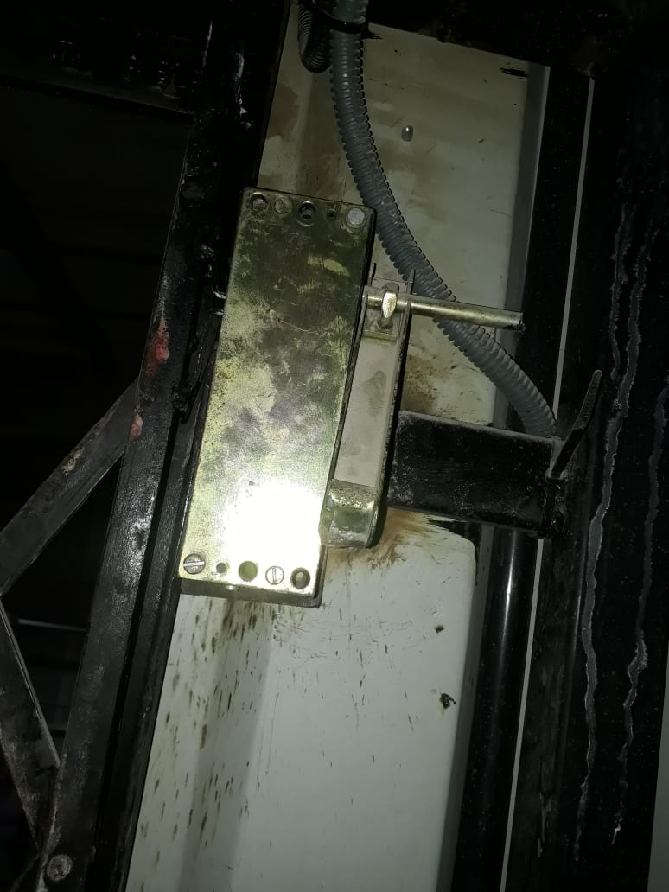
MAGNETIC LATCH

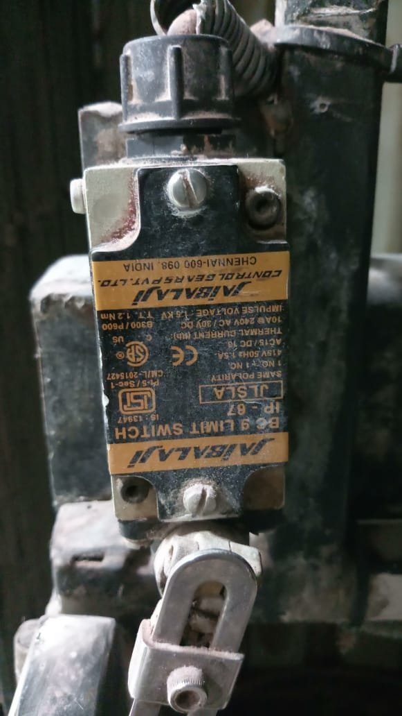
LIMIT SWITCH 01
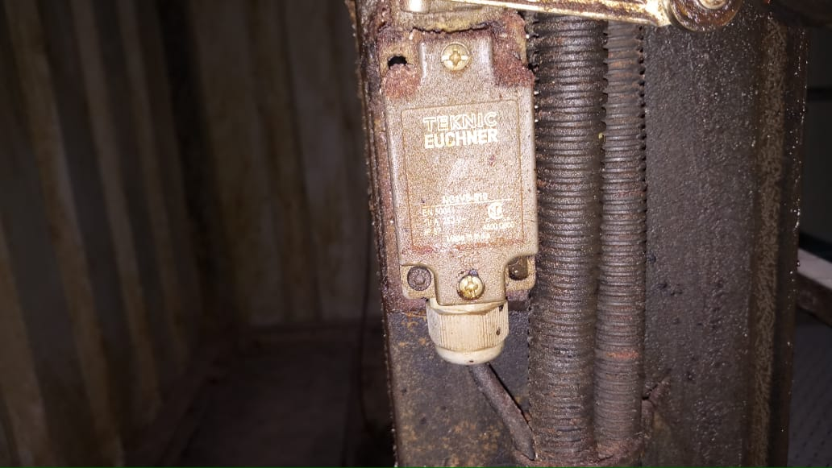
LIMIT SWITCH 02

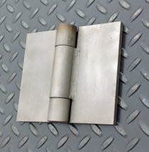
HINGES

